1.3.21
T: Can I use different techniques to create tone when drawing 3D shapes?

Use the examples provided to add tone to your 3D shape:

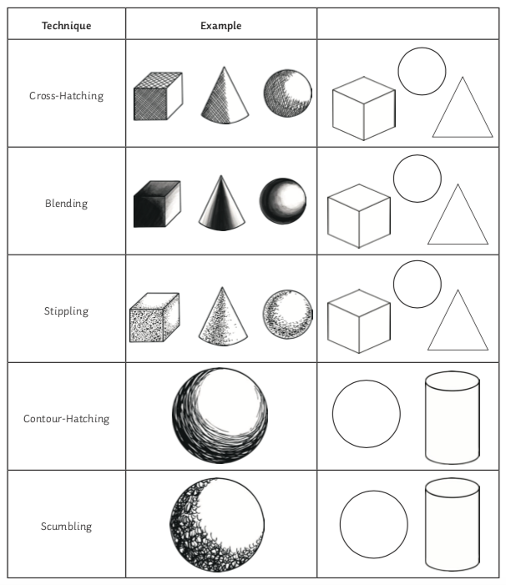
Challenge: Draw a different 3D shape that is not on the worksheet. Choose one of the techniques you have learned today to add to your shape.

